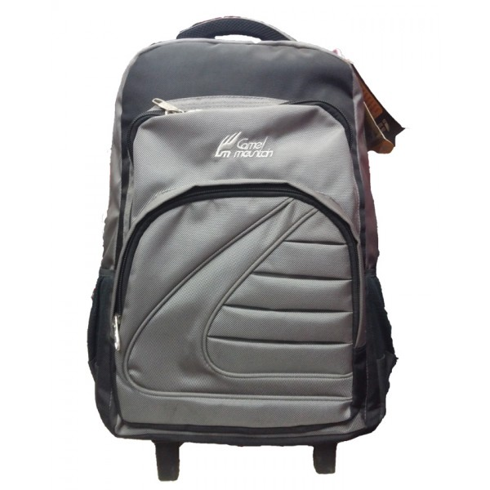

# CAMEL MOUNTAIN SILVER -007

|  |  |
| --- | --- |
| BRAND | CAMEL MOUNTAIN |
| ITEM DIMENSION | 2 x 4 x 12.13inches |
| MODEL NAME | 007 |
| COLOR | SILVER |
| PRICE | **RS 1500** |